

**Year 12 ATAR Human Biology**

**Stage 3 2019**

**Assessment Task 7**

**Test 3- Response to Infection**

**Name:** ……………………………………..

**Teacher:** ………………………………….

|  |  |  |
| --- | --- | --- |
| Part A | Multiple Choice Section | / 20 |
| Part B | Short Answer Section | / 30 |
| Part C | Extended Response Section | / 10 |
| TOTAL | | / 60 |
| PERCENTAGE | | % |

**YEAR 12 ATAR HUMAN BIOLOGY STAGE 3 2019**

**ASSESSMENT TASK 7: Response to Infection Written Test**

**NAME:** ______________________________________________________________

**TEACHER:** __________________________________________________________

**SECTION A: MULTIPLE CHOICE: (20 MARKS):**

***Place an* X *through the correct response:***

1. [A] [B] [C] [D] 11. [A] [B] [C] [D]

2. [A] [B] [C] [D] 12. [A] [B] [C] [D]

3. [A] [B] [C] [D] 13. [A] [B] [C] [D]

4. [A] [B] [C] [D] 14. [A] [B] [C] [D]

5. [A] [B] [C] [D] 15. [A] [B] [C] [D]

6. [A] [B] [C] [D] 16. [A] [B] [C] [D]

7. [A] [B] [C] [D] 17. [A] [B] [C] [D]

8. [A] [B] [C] [D] 18. [A] [B] [C] [D]

9. [A] [B] [C] [D] 19. [A] [B] [C] [D]

10. [A] [B] [C] [D] 20. [A] [B] [C] [D]

**Part A: Short Answers – 30 marks**

***Write your answers in the spaces provided.***

1. Describe four ways pathogens can be transmitted and for each, give an example of a pathogen that can be spread in that way. [4]

2. Describe four of the body’s external defences and explain how each defence protects us from disease. [4]

3. The diagrams below show a disease-causing virus and the same type of virus that has been weakened to make it less harmful.

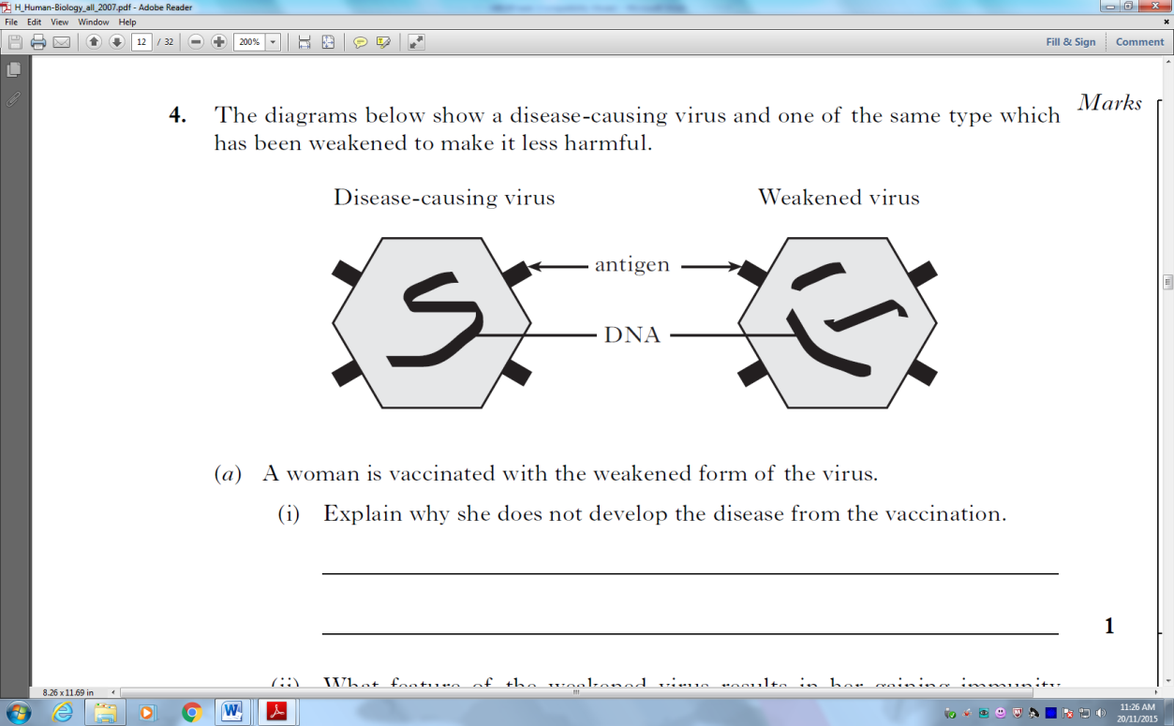

a) What do we call pathogens that have been weakened in this way? [1]

b) A woman is vaccinated with the weakened form of the virus.

i. What feature of the weakened virus results in her gaining immunity from the disease? [1]

ii. Describe two risks associated with using this type of vaccine. [2]

c) What is a vaccine and describe one other method of producing vaccines and give an example of a vaccine produced this way. [4]

__

4. Vaccines exist for most of the common childhood diseases, but many people still do not have their children vaccinated.

a) Describe two reasons why people should vaccinate their children. [2]

b) Describe two reasons why people do not vaccinate their children. [2]

5. a) Describe two changes that occur during the inflammatory response, and explain how each helps to protect the human body from disease. [4]

b) Describe four ways by which antibodies may affect bacteria. [4]

c) What is the difference between T cells and B cells in terms of development? [2]

**END OF SECTION B**

**Section C: Extended Response – 10 marks**

1. Outline the specific immune response that would occur following a common cold infection. [10]



**Year 12 ATAR Human Biology**

**Stage 3 2019**

**Assessment Task 7**

**Test 3 – Response to Infection**

**MULTIPLE CHOICE QUESTION BOOKLET**

**DO NOT MARK THIS BOOKLET IN ANY WAY**

**Indicate your answers on the MULTIPLE CHOICE ANSWER SHEET provided**

**Part A: Multiple Choice – 20 marks**

***Indicate your answers on the Multiple Choice Answer Sheet located in your Answer Booklet.***

1. Which of these options BEST defines pathogens?

a. Bacteria and fungi

b. Bacteria, fungi and viruses

c. Bacteria, fungi and viruses that cause disease

d. Organisms that cause disease

2. Macrophages present in the blood are responsible for:

a. Manufacturing antibodies

b. Engulfing foreign cells or particles

c. Aiding in the clotting of the blood

d. Detoxifying harmful substances

3. The human skin:

a. Acts are a specific defence mechanism

b. Carries helpful bacteria that aid in defending against other pathogenic bacteria

c. Specifically excludes antigens once an individual is immunised against them

d. Is made waterproof by secretion from sweat glands

4. A vector is:

a. A disease-causing micro-organism

b. An insect which becomes infected with a disease

c. A person who does not suffer from a disease but may transmit it to others

d. An organism which transmits disease from one person to another

5. Substances stimulating the production of antibodies are called:

a. Toxins

b. Antigens

c. Carcinomous bodies

d. Antitoxins

6. Which of the following statements is INCORRECT?

a. Bacteria can survive outside living cells

b. Some fungi can cause disease in humans

c. All bacteria are pathogenic

d. Viruses can only multiply inside cells of living organisms

7. Which of the following CANNOT produce active immunity to a disease organism?

a. A dose of the disease

b. Antibodies in breast milk

c. An infection of dead bacteria

d. An injection of weakened virus

8. Regarding antibodies and phagocytes, which statement below is TRUE for antibodies ONLY?

a. They are involved in neutralising an antigen

b. They are involved in protecting the body against foreign micro-organisms

c. They are complex compounds but are not living cells

d. They pass through the walls of blood vessels to a site where micro-organisms have entered the body.

9. What is the main difference between antibiotics and antivirals?

a. Antibiotics are safer to use than antivirals

b. Both are effective against bacteria

c. Antibiotics are effective against bacteria and antivirals are not

d. Both are effective against viruses

10. The graphs below show the effect of two injections of an antigen on the formation of an antibody.

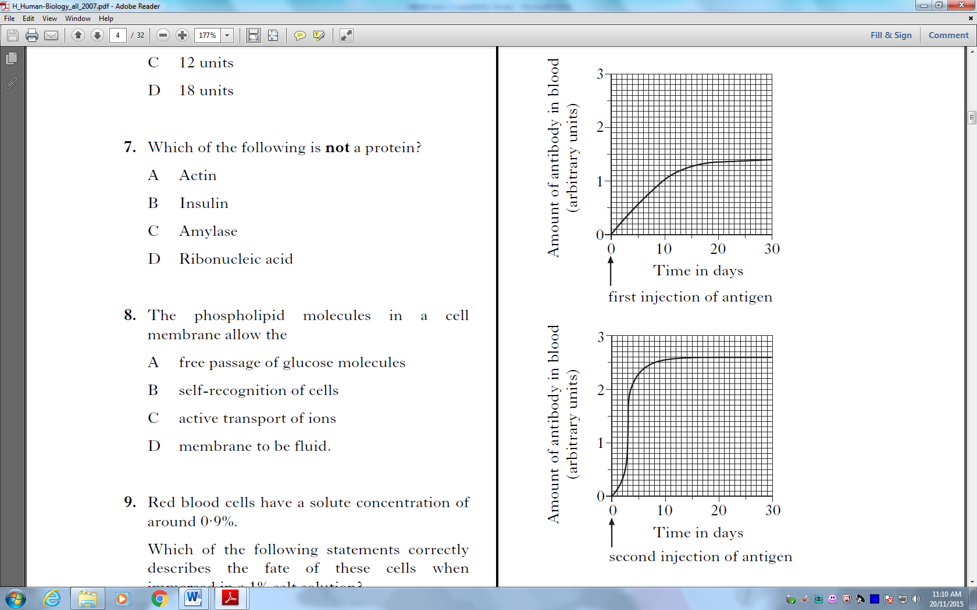

Which of the following statements in NOT supported by the data in these graphs?

a. The secondary response provides a longer period of protection

b. Only the secondary response will provide protection from the disease

c. The secondary response is faster than the primary response

d. The secondary response produces more antibodies than the primary response

11. Which one of the following statements about antibodies is correct?

a. They combine with antigens to form compounds which protect the body against bacteria and viruses

b. They combine with phagocytes to form cells resistant to invading particles

c. They are produced in response to the stimulus of bacteria and viruses entering the body

d. They are produced by antigens present in the body

12. An individual has been inoculated with a particular antigen. Three weeks later the inoculation is repeated. Once would expect that after the second inoculation, antibodies specific to the antigen:

a. Are produced more quickly and in a greater quantity than after the first

b. Are produced more quickly but in a smaller quantity than after the first

c. Are produced more slowly but in a greater quantity than after the first

d. Are not produced in any quantity in the antibodies from the first inoculation are still present in abundance

13. Phagocytes are best described as:

a. Complex chemical compounds consisting of molecules with large number of atoms

b. Arrangement of protein molecules with digestive properties similar to enzymes

c. Living cells which reproduce rapidly at points of bacterial invasion

d. Living cells able to ingest bacteria and cell pieces

14. The “Killer” T-cell or “T-Lymphocyte” cell is part of the:

a. Non-specific immune system

b. Inflammatory response

c. Antibody-mediated response

d. Cell-mediated response

15. An antigen is a substance that:

a. Is called a toxin or virus

b. Is found of the surface of viruses

c. Is found in bacteria

d. Produces an immune response

16.How does immunisation against diseases such as diphtheria and polio limit the spread of infectious diseases?

a. Immunisation kills the pathogens

b. Immunisation supresses or reduces the immune response and associated inflammation

c. Immunisation strengthens the first-line defence barriers and prevents entry of the pathogens into the body

d. Immunisation reduces the multiplication of the pathogen in immunised hosts and this reduces the change of other become becoming infected

17. Measures such a protective clothing, gloves and surgical masks help reduce the risk of infections by:

a. Sterilising the surrounding air

b. Providing an alternative pathway for invading pathogens

c. Providing a mechanical barrier that acts as an obstacle to invading pathogens

d. Signalling to others that the protected person may be carrying a disease

18. Topical preparations to prevent or treat infections are those which are applied:

a. Orally

b. To surfaces around the home such as kitchen benches

c. To relieve pain

d. To the skin

19. Which of the following is NOT a component of the body’s external defence against disease?

a. Wax in the ears

b. Alkaline conditions in saliva

c. Lavers of mucus in the respiratory tract

d. Acidic environment in the urethra

20. Which of the following is NOT a strategy people can undertake to help reduce the spread of disease?

a. Wearing surgical masks

b. Covering their mouths when coughing

c. Wiping surfaces with disinfectant

d. Taking pain relief drugs

**END OF SECTION A**